Health and safety policy statement

ESO Education and Training (NW) LTD. Seek excellence in every aspect of its business and is committed to ensuring the firm complies with its legal duty under the Health & Safety at Work Act 1974. The company recognises and accepts its statutory responsibility as an employer to provide, in so far as is reasonably practical, a safe and healthy work environment for all employees, visitors, and contract employees.
Our statement of general policy is: -
• to provide adequate control of the health and safety risks arising from our work
activities.
• Provide sufficient resources to enable the implementation of this policy.
• to consult with our employees on matters affecting their health and safety
• to provide and maintain safe plant and equipment.
• to ensure safe handling and use of substances.
• to provide information, instruction and supervision for employees.
• to ensure all employees are competent to do their tasks and to give them adequate training.
• to prevent accidents and cases of work-related ill health.
• to maintain safe and healthy working conditions; and
• to review and revise this policy as necessary at regular intervals
• Ensuring Risk Assessments are undertaken to identify hazards and to implement the necessary corrective measures to remove or minimise the risk to individuals.
• Providing employees with the necessary information, instruction, training and supervision, to enable them to carry out their duties competently
signed
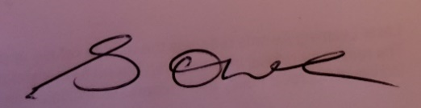 Simon Owen (Director) February 2024

